Project Design Phase-II
Technology Stack (Architecture & Stack)

Date | 09-07-2026
Team ID
Project Name | ONLINE COMPLAINT REGISTRATION
Maximum Marks | 4 Marks

Technical Architecture: Online Complaint Registration

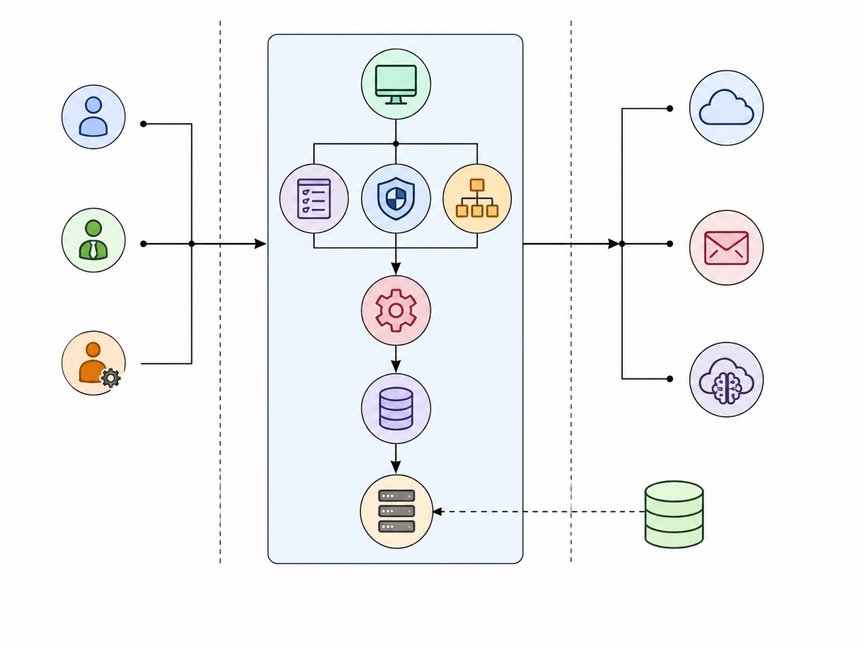
Table-1 : Components & Technologies:
S.No | Component | Description | Technology
 | User Interface | Web-based user interface for Ordinary Users, Agents, and Admin | React.js, HTML5, CSS3, Bootstrap, JavaScript
 | Application Logic-1 | User Authentication, Complaint Management, Feedback Management, Dashboard | Node.js, Express.js
 | Application Logic-2 | Real-time communication between User and Agent | Socket.io
 | Application Logic-3 | Email Notifications and Password Reset | Nodemailer
 | Database | Stores Users, Complaints, Chats, Feedback, Agent Information | MongoDB (NoSQL), Mongoose ODM
 | Cloud Database | Not Applicable (Project developed using Local MongoDB) | N/A
 | File Storage | Stores Complaint Images and Resolution Images | Multer (Local File System)
 | External API-1 | REST API Communication between Frontend and Backend | Axios
 | External API-2 | Password Reset Email Service | Gmail SMTP using Nodemailer
 | Machine Learning Model | Not Used in this Project | N/A
 | Infrastructure (Server / Cloud) | Backend runs on Local Server, Frontend on Vite Development Server | Node.js Local Server, MongoDB Local Server

Table-2: Application Characteristics:
S.No | Characteristics | Description | Technology
 | Open-Source Frameworks | Open-source technologies used for frontend, backend, database, routing, styling, and real-time communication | React.js, Node.js, Express.js, MongoDB, Mongoose, Bootstrap, Socket.io
 | Security Implementations | Secure authentication using JWT, encrypted passwords using bcrypt, role-based authorization, request validation, Helmet security headers, CORS configuration | JWT, bcryptjs, Express Validator, Helmet, CORS
 | Scalable Architecture | Three-tier MERN architecture separates Presentation, Business Logic, and Database layers, making future enhancements easier | MERN Stack (React, Express, Node.js, MongoDB)
 | Availability | Web application accessible through modern browsers and designed to work on desktop, laptop, tablet, and mobile devices with responsive UI | React.js, Bootstrap, Responsive CSS
 | Performance | Fast REST API communication, asynchronous request handling, efficient MongoDB queries, optimized React rendering, lightweight JSON data exchange | Axios, Express.js, MongoDB, React.js

References:
https://c4model.com/
https://developer.ibm.com/patterns/online-order-processing-system-during-pandemic/
https://www.ibm.com/cloud/architecture
https://aws.amazon.com/architecture
https://medium.com/the-internal-startup/how-to-draw-useful-technical-architecture-diagrams-2d20c9fda90d

